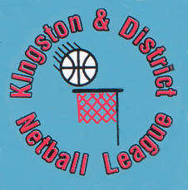

Kingston & District Netball League
www.kdnl.co.uk

CODE OF CONDUCT GUIDELINES
The Kingston & District Netball League (the League) regards discrimination, harassment, bullying or victimisation as serious misconduct for which members will be liable to appropriate disciplinary action.
All officials, clubs, players, volunteers, spectators etc (members) involved in the League have the responsibility to respect, act in accordance with and thereby support and promote the spirit and intentions of these guidelines.
All League members must undertake that they will:-
- not abuse or misuse any relationship of trust, or position of power, or influence held within their team, club and the League.
- conduct themselves in an appropriate manner and co-operate and respect other League members.
- never argue with a match official during a game.
- exercise self-control and understand that verbal, emotional and physical abuse of officials, coaches, spectators, deliberately distracting or provoking an opponent is not acceptable or permitted behaviour.
- treat all participants with respect, never bully or take unfair advantage of another participant.
- display modesty in victory and graciousness in defeat.
- comply with all statutory anti-doping and alcohol policies and regulations.
- abide by any disciplinary sanctions imposed by the League and match officials during the course of matches.
- not use social media technology to bring the game into disrepute or make any inappropriate comments about fellow competitors, coaches, officials, volunteers or spectators.
- ensure correct club kit is worn at all times during play and for umpires to be ideally in white or a neutral colour.
- abide by the League's Rules & Regulations.
All clubs should ensure that they have a member who is fully conversant with Safeguarding and/or Child Protection policies and procedures.
May 2017
KDNL Committee

